**Walchand College of Engineering, Sangli**

**Department of Computer Science and Engineering**

**Third Year – Programming Laboratory-3 (2020-21)**

PRN:2018BTECS00061

**Practical No. 8(Batch – T3)**

To design and develop web pages using HTML elements and applying CSS text formatting colour and background properties.

Link : <https://github.com/nishibhate/pl.git>

**Problem Statement :**

Apply CSS to the web pages developed in the Practical No. 5B (All Problem Statements). It should satisfy following requirements:

1. Text Formatting properties such as Font Size, Font Style, Text Alignment, etc.

2. Colour and Background properties such as Background colour, RGB and HEX values instead of colour names, etc.

3. Borders and Margin properties such as Border Width, Border Colour, Margins, etc.

4. Inline styles, internal (embedded) style sheets and external style sheets.

5. Different Selectors for applying styles.

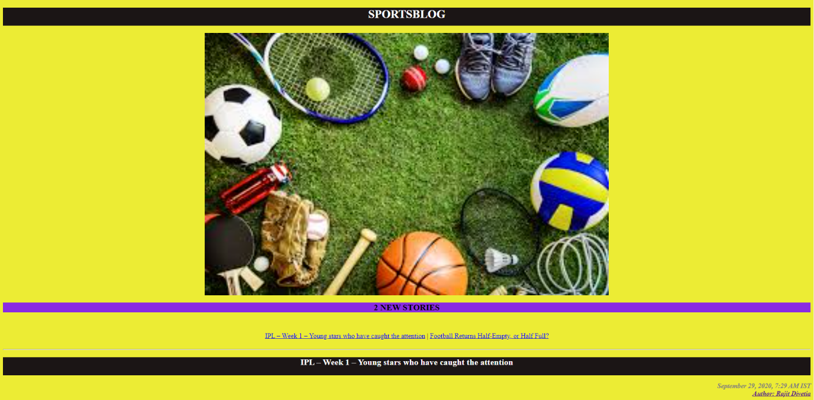**Problem Statement 1:**

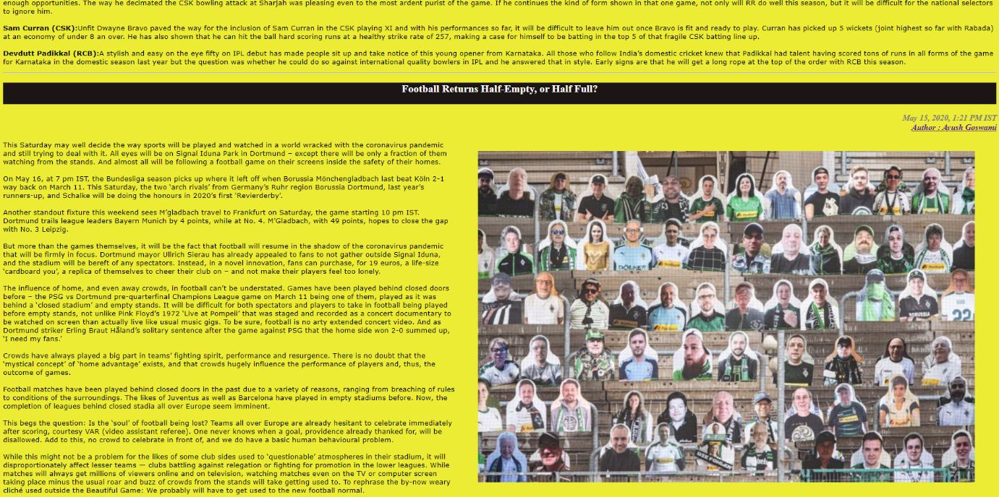

**Problem Statement 2:**

Design and develop a static web page using HTML for following requirement. Access it locally and in LAN using web server. It should have following sections:

1. Problem Statement: Write a program in any language to find the sum of the series 1 +11 + 111 + 1111 + ... n terms.

2. Code

3. Sample Input

4. Sample Output

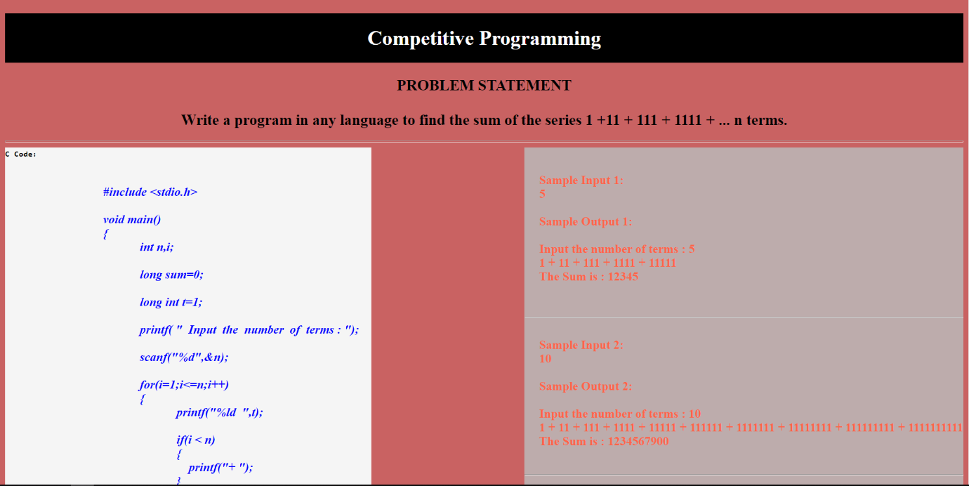 5. Variables used in the program

6. Complexity

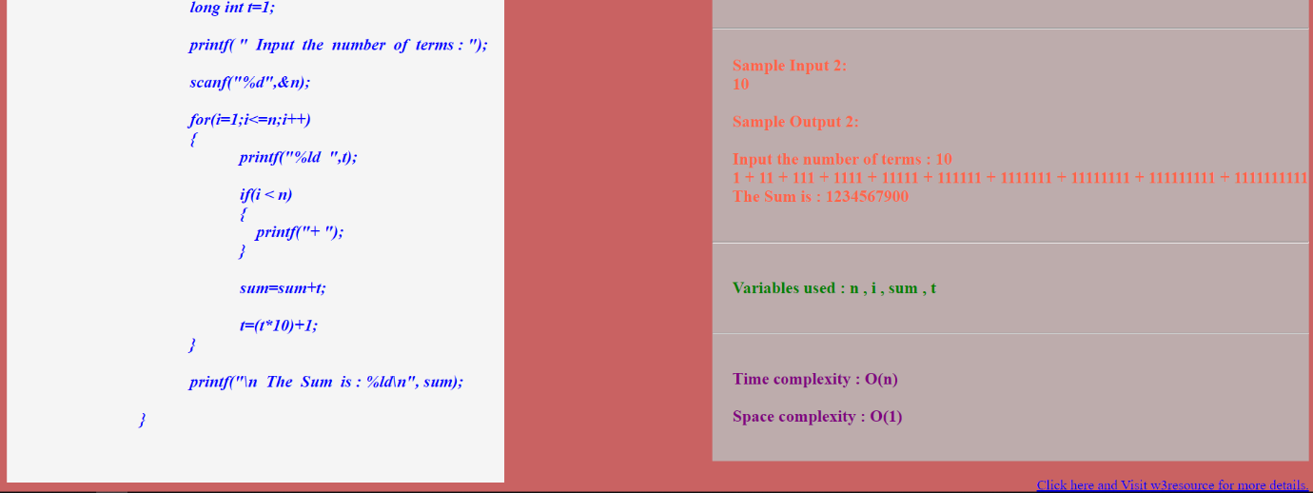

**Problem Statement 3:**

Design and develop a static web page using HTML for following requirement. Access it locally and in LAN using web server.

It should have following sections:

1. Any three quotes from https://www.brainyquote.com/ with the name of person who quoted it

